* [Lab 3 - Using Auto-Scaling with AWS Lambda](https://globalknowledge.qwiklab.com/focuses/17009" \l "lab-3-using-auto-scaling-with-aws-lambda)
  + [Accessing the AWS Management Console](https://globalknowledge.qwiklab.com/focuses/17009#accessing-the-aws-management-console)
  + [Task 1: Creating a Notification for an Auto Scaling Event](https://globalknowledge.qwiklab.com/focuses/17009#task-1-creating-a-notification-for-an-auto-scaling-event)
    - [Task 1.1: Create an SNS Topic](https://globalknowledge.qwiklab.com/focuses/17009#task-1-1-create-an-sns-topic)
    - [Task 1.2: Create Notification for Launch Event](https://globalknowledge.qwiklab.com/focuses/17009#task-1-2-create-notification-for-launch-event)
  + [Task 2: Handling a Lifecycle Event Notification](https://globalknowledge.qwiklab.com/focuses/17009#task-2-handling-a-lifecycle-event-notification)
    - [Task 2.1: Create an IAM Role to Grant the Lambda Function Permission to Access AWS Services](https://globalknowledge.qwiklab.com/focuses/17009#task-2-1-create-an-iam-role-to-grant-the-lambda-function-permission-to-access-aws-services)
    - [Task 2.2: Create a Lambda Function](https://globalknowledge.qwiklab.com/focuses/17009#task-2-2-create-a-lambda-function)
    - [Task 2.3: Scale Out Auto Scaling Group to Trigger Lifecycle Event Hook](https://globalknowledge.qwiklab.com/focuses/17009#task-2-3-scale-out-auto-scaling-group-to-trigger-lifecycle-event-hook)
  + [Lab Complete](https://globalknowledge.qwiklab.com/focuses/17009#lab-complete)

Lab 3 - Using Auto-Scaling with AWS Lambda

In this lab, you will set up a custom action, defined in an AWS Lambda function, to automatically create a snapshot of new Amazon EC2 instances launched by Auto Scaling and tag them.

In this lab, you will:

* Create an Amazon Simple Notification Service (Amazon SNS) topic as a notification target for lifecycle events.
* Set up your Auto Scaling group to send notifications when new EC2 instances are launched.
* Set up the roles and permissions required.
* Create a Lambda function that should be invoked when it receives a message from your Amazon SNS topic that an Auto Scaling event has occurred.
* The Lambda function will tag the new instance and create a snapshot using API calls.

Your environment will function this like this when you're done:

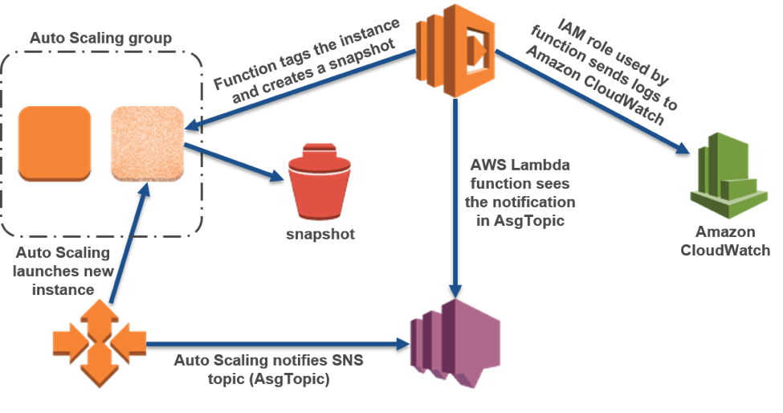

**Objectives**

After completing **this** lab, you will be able to:

* Manually scale an Auto Scaling group.
* Implement an Auto Scaling lifecycle hook that invokes a Lambda function.

**Prerequisites**

This lab requires:

* Access to a notebook computer with Wi-Fi running Microsoft Windows, Mac OS X, or Linux (Ubuntu, SuSE, or Red Hat)
* For Microsoft Windows users: Administrator access to the computer
* An Internet browser such as Chrome, Firefox, or IE9 (previous versions of Internet Explorer are not supported)

**Duration**

This lab will require around **60 minutes** to complete.

Accessing the AWS Management Console

1. To the right of the lab title, click **Start Lab** to launch your Qwiklabs.

C:\Users\student\Desktop\architect\Architecting on AWS - Lab 3 - Using Auto Scaling with AWS Lambda _ Qwiklabs + globalknowledge_files\start.png

1. On the **Connect** tab of the Qwiklabs page, copy the **Password** to the clipboard and then click **Open Console**.

C:\Users\student\Desktop\architect\Architecting on AWS - Lab 3 - Using Auto Scaling with AWS Lambda _ Qwiklabs + globalknowledge_files\open.png

1. Sign in to the AWS Management Console using the following steps:

* For **User Name**, type **awsstudent**
  + For **Password**, paste the password copied from the clipboard.
  + Click **Sign In**.

Task 1: Creating a Notification for an Auto Scaling Event

In this task, you will configure the lab’s Auto Scaling group to send lifecycle event notifications to an SNS topic.

**Task 1.1: Create an SNS Topic**

In this section, you will create an SNS topic that the Auto Scaling group will use as a notification target. The Auto Scaling group will send notifications to this topic when new EC2 instances are launched.\*\*

1. In the **AWS Management Console** , in the **Services** menu, click **Simple Notification Service**.
2. Click **Get Started**.

**Note** If you don't see a **Get Started** button, you can just skip to the next step.

1. Click **Create topic**.
2. In the Create new topic dialog box, enter the following values:

* For **Topic name**, type 
* For **Display name**, type 

1. Click **Create topic**.

**Task 1.2: Create Notification for Launch Event**

In this section, you will configure the Auto Scaling group to send notifications to the SNS topic when new EC2 instances are launched.

1. In the **AWS Management Console** , on the **Services** menu, click **EC2**.
2. In the navigation pane, click **Auto Scaling Groups**.
3. Click **qls-XXXX-XXX-AppAutoScalingGroup-XXX** (Auto Scaling Group:1).

You should now see the Auto Scaling Group that was created for you automatically for this lab.

1. On the **Notifications** tab, click **Create notification**.
2. For **Send a notification to** , make sure that **AsgTopic** is selected.
3. For **Whenever instances** , ensure that only **launch** is selected. All other options should not be selected.
4. Click **Save**.

Task 2: Handling a Lifecycle Event Notification

In this task, you will develop a Lambda function that will be invoked by Amazon SNS when a lifecycle event notification is received. The Lambda function will extract the EC2 instance ID from the event notification and add a tag to the EC2 instance.

**Task 2.1: Create an IAM Role to Grant the Lambda Function Permission to Access AWS Services**

In this section, you will create an IAM role that grants permissions to perform operations on EC2 instances, notify Auto Scaling that the custom action associate with the lifecycle hook is complete, and log messages by using Amazon CloudWatch.

You will associate this role with your Lambda function when you create your Lambda function later.

**You will associate this role with your Lambda function when you create your Lambda function later.**

1. On the **Services** menu, click **IAM**.
2. In the navigation pane, click **Roles**.
3. Click **Create new role**.
4. On the **Select role type** page, under **AWS Service Role** , in the row for **AWS Lambda**, click **Select**.
5. On the **Attach Policy** page, for **Filter**, type 
6. Select **AmazonEC2FullAccess**.
7. Click **Next Step**.
8. For **Role Name**, type 
9. Click **Create Role**.
10. Click **EC2TagSnapLambdaRole**.
11. On the **Permissions** tab, expand **Inline Policies by clicking on it**, and click **click here**.
12. Select **Custom Policy**, and then click **Select**.
13. For **Policy Name**, type 
14. For **Policy Document**, copy and paste the command below. This policy allows the Lambda function to send log messages to Amazon CloudWatch.

Copy Code Block Copy Code Block

{

"Version": "2012-10-17",

"Statement": [

{

"Action": [

"logs:CreateLogGroup",

"logs:CreateLogStream",

"logs:PutLogEvents"

],

"Resource": "arn:aws:logs:\*:\*:\*",

"Effect": "Allow"

}

]

}

1. Click **Apply Policy**.

**Task 2.2: Create a Lambda Function**

In this section, you will create a Lambda function that will be invoked by Amazon SNS when a lifecycle event notification is received. The Lambda function will extract the EC2 instance ID from the event notification and add a tag to the EC2 instance.\*\*

**The Lambda function will be developed with Python 2.7 and the** [**Boto 3 SDK**](https://boto3.readthedocs.org/en/latest/)**.**

1. On the **Services** menu, click **Lambda**.
2. Click **Get Started Now**. If **Get Started Now** does not appear, proceed to the next step.
3. On the **Select blueprint** page, click **Blank Function**.
4. On the **Configure triggers** page, click the empty square to the left of the Lambda icon.
5. In the drop-down list that appears, click **SNS**.
6. For **SNS topic**, make sure that **AsgTopic** is selected. Amazon SNS will invoke this Lambda function when AsgTopic receives an Auto Scaling lifecycle event notification.
7. Select the **Enable trigger** check box.
8. Click **Next**.
9. On the **Configure function** page, for **Name** , type 
10. For **Description**, type 
11. For **Runtime**, click **Python 2.7**.
12. For **Code entry type** , make sure that **Edit code inline** is selected.
13. Delete all of the code that appears below the **Code entry type** section so that the field is empty.
14. Copy and paste the Lambda function code below, into the empty field.

Copy Code Block Copy Code Block

from \_\_future\_\_ import print\_function

import json

import boto3

print('Loading function')

def lambda\_handler(event, context):

# print("Received event: " + json.dumps(event, indent=2))

# Extract the EC2 instance id from the Auto Scaling lifecycle event notification

message = event['Records'][0]['Sns']['Message']

autoscalingInfo = json.loads(message)

ec2InstanceId = autoscalingInfo['EC2InstanceId']

print ("\*\*\*Adding tag to EC2 instance with id: " + ec2InstanceId)

# Add a tag to the EC2 instance: Key = ManualScaling, Value = Yes

ec2 = boto3.client('ec2')

response = ec2.create\_tags(

DryRun=False,

Resources=[

ec2InstanceId

],

Tags=[

{

'Key': 'ManualScaling',

'Value': 'Yes'

},

]

)

ec2 = boto3.resource('ec2')

print ("\*\*\*Creating snapshot of volumes attached to EC2 instance with id: " + ec2InstanceId)

for v in ec2.volumes.filter(Filters=[{'Name': 'attachment.instance-id', 'Values': [ec2InstanceId]}]):

print(v.volume\_id)

description = 'autosnap-%s-%s' % ( ec2InstanceId, v.volume\_id )

if v.create\_snapshot(description):

print("\t\tSnapshot created with description [%s]" % description)

return "ec2InstanceId"

1. For **Role**, make sure **Choose an existing role** is selected.
2. For **Existing role**, click **EC2TagSnapLambdaRole**. This gives AWS Lambda the execution permissions that you have specified for this role.
3. Expand **Advanced settings** and for **Timeout**, change the time to **3** min **0** sec.
4. Leave other values with default settings, and then click **Next**.
5. Review the settings for your function and click **Create function**.

**Tip** On the **Monitoring** tab, you can view CloudWatch metrics related to your Lambda function. Click **View logs in CloudWatch** to view the messages logged by your Lambda function.

Because the Lambda function has not been invoked yet, the metrics will currently display zero invocation count.

**Task 2.3: Scale Out Auto Scaling Group to Trigger Lifecycle Event Hook**

In this section, you will increase the desired capacity of the lab's Auto Scaling group from 1 to 2. The Auto Scaling group will launch a new EC2 instance to meet the increased capacity requirement. Auto Scaling will send a lifecycle event notification to AsgTopic (SNS topic). Amazon SNS will invoke EC2TaggerLambdaFunction when it receives the event notification.

1. On the **Services** menu, click **EC2**.
2. In the navigation pane, click **Auto Scaling Groups**.
3. On the **Details** tab, click **Edit**.
4. For **Desired**, type 
5. Click **Save**.
6. On the **Activity History** tab, monitor the progress of the new EC2 instance that is being launched. Wait for the status to change to *Successful*.

**Note** It may take 30 seconds for the second instance to appear in that list. Continue refreshing the page if your new instance doesn't appear.

1. In the navigation pane on the left side of the page (not the tab at the bottom of the page), click **Instances**.
2. Click the row for the instance that has the most recent launch time. You might have to scroll to the right to view the **Launch Time** column for your instance.
3. On the **Tags** tab, you will see a tag with **ManualScaling** as the key, and **Yes** as the value. This tag was added to the EC2 instance by EC2TaggerLambdaFunction.
4. In the navigation pane, click **Snapshots**.

In the snapshot window, you will see snapshots of the volumes attached to the new instance.

Lab Complete

Congratulations! You have successfully completed the lab. To clean up your lab environment, do the following:

1. To sign out of the **AWS Management Console** click **awsstudent** in the navigation bar, and then click **Sign Out**.
2. Return to the **qwikLABS** page where you launched your lab and click **End**.

© for the use of: shweta\_misra@fanniemae.com

* Connect
* Lab Details
* Addl. Info
* **Lab Connection**   
  Please follow the lab instructions to connect to your lab

**Warning:** Do not transmit data into the AWS Console that is not related to Qwiklabs or the lab you are taking.

* + **AWS Console Details**
  + **Access Key Details**
  + [Show Access Keys](https://globalknowledge.qwiklab.com/focuses/17009#accessKeyIdModal)
  + **Key Pair Details**

|  |  |
| --- | --- |
| **Setup Time (min.)** | 6 |
| **Duration (min.)** | 120 |
| **Access (min.)** | 120 |

|  |
| --- |
| **Tags:** [**AWS-100-ARC-51-lab-3-autoscaling**](https://globalknowledge.qwiklab.com/tags/AWS-100-ARC-51-lab-3-autoscaling)  **Lab Description:** Arch on AWS - Lab 3  **Lab Creator:** qwikLABS publisher  **Date Created:** May 17, 2017 14:22  **AWS Region::** [us-west-2] **US West (Oregon)** |

Additional Lab Information:

×

**Access Key Details**

Use access keys to make secure REST or Query protocol requests to any AWS service API.

Close